Playgroup Tasmania
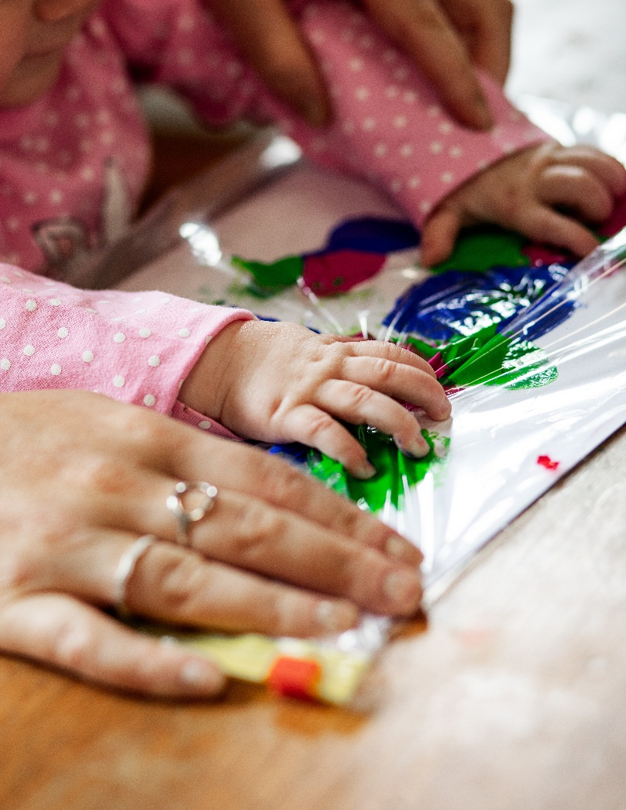
Child Safety and Wellbeing
Commitment (Easy Read)


What is in this Document?

About Playgroup Tasmania 3
About this Document 4
You Can Ask for Help 5
Our Promise to Keep Children Safe 6
What We Believe In 7
What We Do To Keep Children Safe 8
Documents to Keep Children Safe 10
How you can speak up or give feedback 11
Word list 12
Acknowledgements 16


About Playgroup Tasmania
Playgroup Tasmania wrote this document.
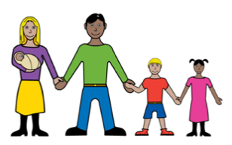
Playgroup Tasmania helps families and caregivers with young children.

We create places where children and families can:
- play
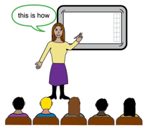
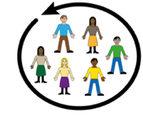
- learn
- connect.
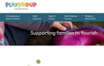


You can learn more about Playgroup Tasmania on our website: playgrouptas.org.au/


About this Document
This document explains Playgroup Tasmania’s promise to keep all children safe and well.
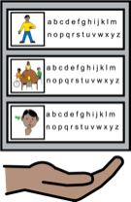
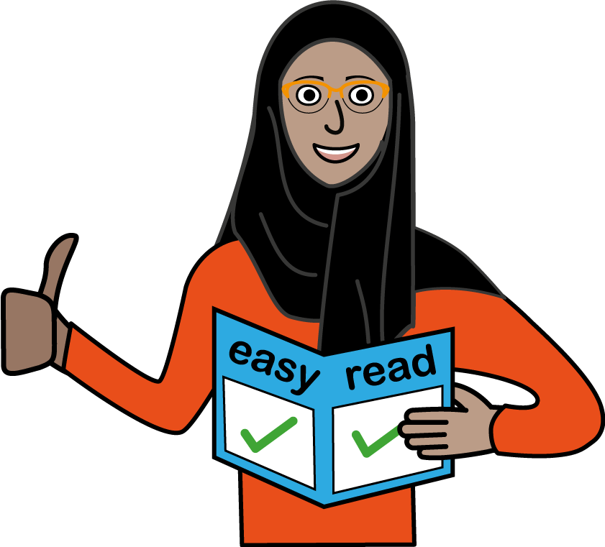
This document is an Easy Read version of another document.
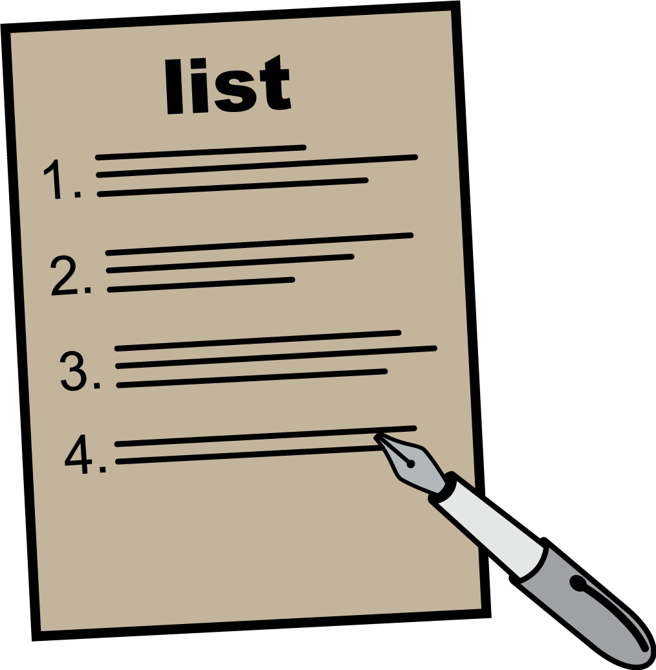
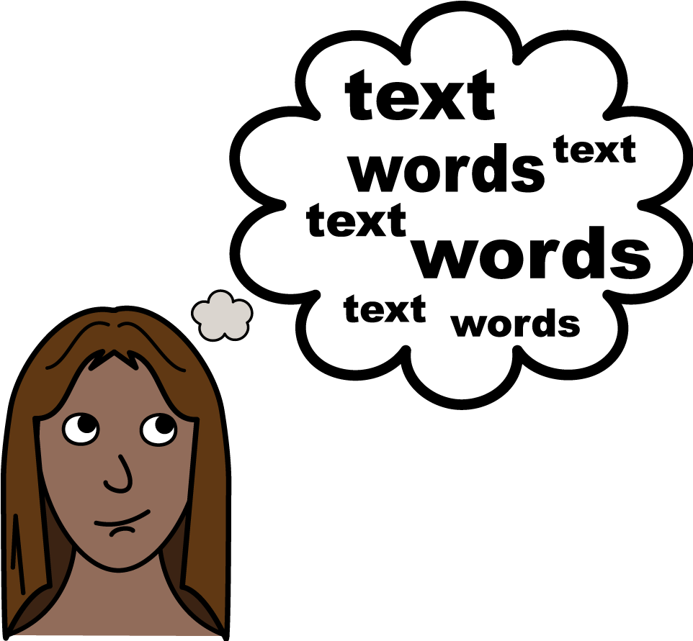
This document is written in an easy to read way. Hard words are written in bold underline the first time we use them.
We explain what these words mean. There is a list of these words at the end of this document.


You Can Ask for Help
You can ask for help to read this document.
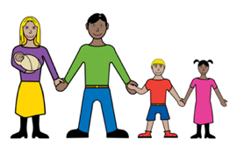
You can ask someone you trust, like:
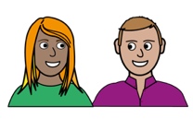
- a family member
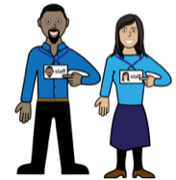
- a friend
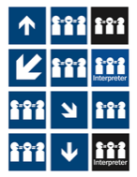
- a support worker
- an interpreter.


Our Promise to Keep Children Safe
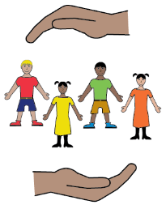
We promise to do all we can to keep all children safe and well.
Everyone has a role in keeping children safe.
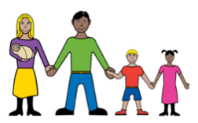
This includes:
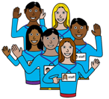
- children, parents and caregivers
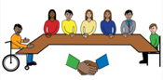
- staff and volunteers
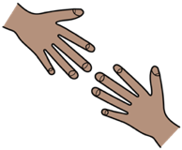
- the Board
- anyone who helps at playgroup.

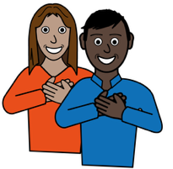
What We Believe In
At Playgroup Tasmania we are:
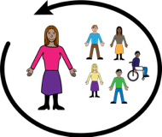
- Inclusive – we welcome everyone

- Honest – we tell the truth
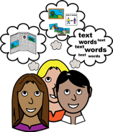
- Creative – we find new ways to help families
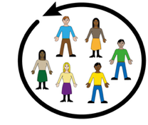
- Connected – we work together with others.

We also respect Aboriginal culture.

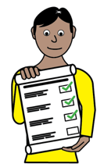
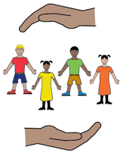
What We Do To Keep Children Safe
We:
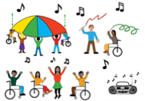
- make sure playgroups are:
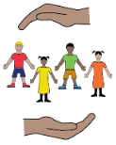
  - fun
  - safe

  - friendly
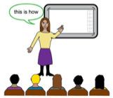

- listen to children and families and do what we can to help
- teach volunteers and staff about safety
- make sure we hire safe and friendly staff
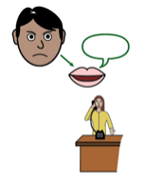
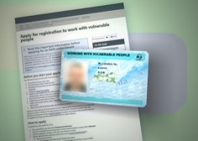
- check that volunteers and staff have
Registration to Work with Vulnerable People
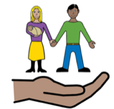

- respond and act on any worries or complaints
- keep our online spaces safe for families.

This includes our:
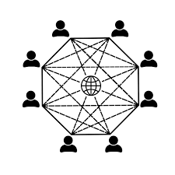
- Facebook posts

- Online groups
- Online meetings.


Documents to Keep Children Safe

We write and check our important documents to help keep children safe.
These include:
- our Vision – what we want to achieve.
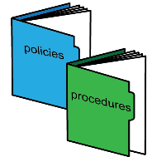
- our Policies and Procedures – documents about how we do things.
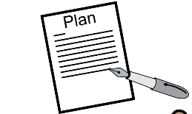
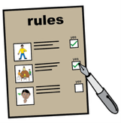
- our Code of Conduct – rules about what is okay and not okay for people who work or help at playgroup.
- our Plans – ideas to make playgroups even better.

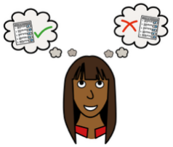
How you can speak up or give feedback
You can tell us if you have:
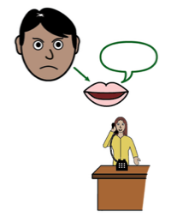
- a worry
- complaint
- or feedback.


Email: admin@playgrouptas.org.au
Phone 1300 035 350

Fill in our feedback form on the
Playgroup Tasmania website:
playgrouptas.org.au/tell-us-what-you-think

Word list
Aboriginal: means the First Peoples of Australia.
Aboriginal people have their own cultures, languages and traditions.
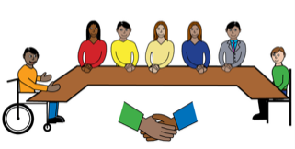
Our Board: is a group of volunteers who help run Playgroup Tasmania.

Code of Conduct: rules about what is okay and not okay for people who work or help at playgroup
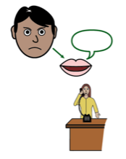
Complaint: telling someone when something is wrong or not fair.
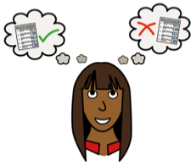
Feedback: is what people tell you about your work or actions. It can help you learn or make changes.

- Good feedback (compliment) tells you what you are doing well.

- Bad (or negative) feedback (complaint) tells you what could be better.
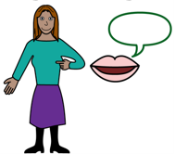
- Suggestion gives ideas about changing things to make them better
Inclusive: welcoming everyone.
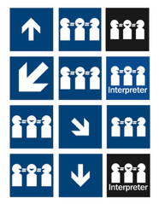
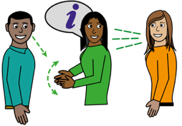
An Interpreter is a person who helps someone understand information or speech. They do this by hearing or reading the information and sharing it in a different language.
This could be in:
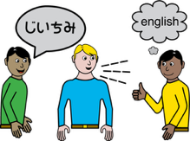
- Auslan or sign language
- a language other than English.

Plan: ideas to make playgroups even better.
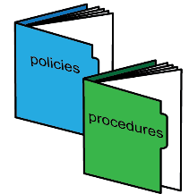
Policies and Procedures: documents about how to do things.
Policies say what is important to us and what we believe.
Procedures explain the steps we follow to make sure things are done safely and fairly
Vision: ideas what we want to achieve.
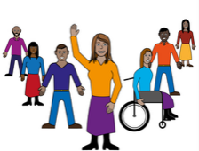
Volunteer: someone who helps without being paid.

A Registration to Work with Vulnerable People checks, approves and keeps track of people who work or volunteer with children or other people who might need extra care or protection.


In Tasmania, this check is done by the Tasmanian Government Department of Justice.

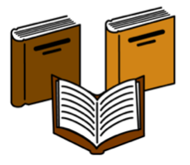
Acknowledgements

Who wrote this document?
Heidi La Paglia Consulting wrote this document in 2025 for Playgroup Tasmania.

Copyright
© Copyright
Playgroup Tasmania. 2025.

All intellectual property rights, including copyright and patents, in this book is owned and licensed by Playgroup Tasmania.

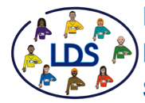
The images used in this fact sheet
Learning Disability Service Easy on the I Images.
Google images. Creative Commons Licenses.
Pexels Images.
Wikipedia Commons Images.

